Athena Bug Report Sample

Bug ID BUG-001
Title Unexpected numeric indicator displayed in question panel
Module Quiz Page
Environment Chrome 120, Windows 11
Build Version NA
Severity Low
Priority Medium
Reported By Nilava (QA Automation Engineer)
Date
13-April-2026
Frequency Always
Precondition User is logged into Athena onboarding quiz
Steps to Reproduce 1. Open the onboarding quiz page.
2. Navigate to Question 1
3. Observe the right-side panel header

Actual Result

Expected Result
A number "1" is displayed at the top of the right panel, which is unrelated to the question or options.

The number "1" should not be displayed, or it should be properly labelled if it represents a question number or score.

Impact
This may confuse users as it appears unrelated to:
- Question number
- Selected option
- Score
- Progress

Evidence / Screenshot
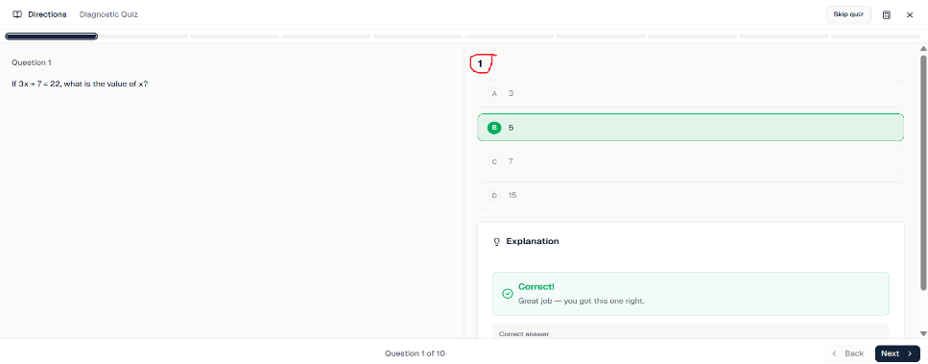
Bug ID BUG-002
Title Back button remains disabled after navigating to the next question
Module Quiz Page
Environment Chrome 120, Windows 11
Build Version NA
Severity Medium
Priority High
Reported By Nilava (QA Automation Engineer)
Date
13-April-2026
Frequency Always
Precondition User is logged into Athena onboarding quiz
Steps to Reproduce 1. Open the onboarding quiz page.
2. Start from Question 1
3. Click Next button
4. Navigate to Question 2
5. Observe the Back button

Actual Result Back button remains disabled even after navigating to Question 2.

Expected Result Back button should be enabled once the user moves past Question 1, allowing navigation to the previous question.

Evidence / Screenshot
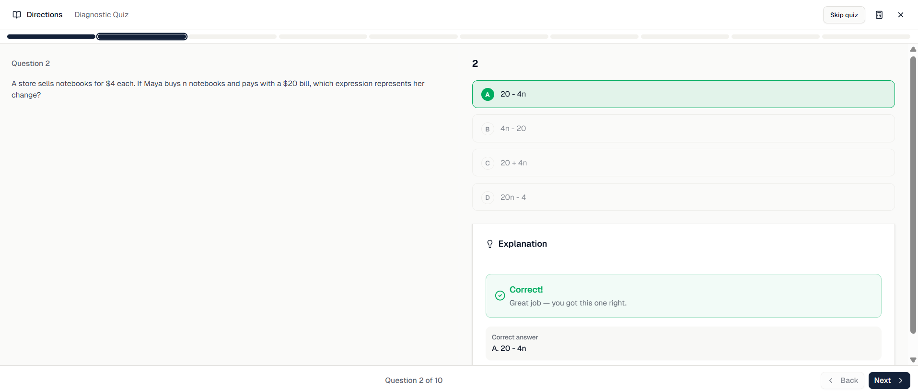

Bug ID BUG-003
Title Next button allows skipping learning section after incorrect answer
Module Quiz Page
Environment Chrome 120, Windows 11
Build Version NA
Severity Medium
Priority High
Reported By Nilava (QA Automation Engineer)
Date
13-April-2026
Frequency Always
Precondition User is logged into Athena onboarding quiz
Steps to Reproduce 1. Open the onboarding quiz page.
2. Select an incorrect answer
3. Click Next immediately
4. Observe the lesson/suggestion section behaviour

Actual Result User can click Next immediately after selecting a wrong answer, navigating to the next question. The lesson/suggestion section appears only afterwards.
Expected Result
When a user selects an incorrect answer:
- The lesson/suggestion section should appear immediately
- The Next button should be disabled
- User should complete/read the lesson first
- Only then should Next be enabled
Impact
- Users can skip learning content
- Reduces the educational effectiveness of the diagnostic quiz
- Incorrect knowledge not corrected
- Users may repeat mistakes in later questions
- Breaks intended adaptive-learning flow
- Poor learning experience
- Makes the suggestion/lesson section meaningless.
Evidence / Screenshot
Please find the Loom video link below:
https://www.loom.com/looms/videos/Athena-SAT-project-Issues-e043729662764c6498e07122fca58436

Bug ID BUG-004
Title Mark for Review option does not mark the question
Module Quiz Page
Environment Chrome 120, Windows 11
Build Version NA
Severity Medium
Priority Medium
Reported By Nilava (QA Automation Engineer)
Date
13-April-2026
Frequency Always
Precondition User is logged into Athena onboarding quiz
Steps to Reproduce 1. Open the onboarding quiz page.
2. Click Mark for Review
3. Navigate away and return

Actual Result Question is not marked for review, and no visual indicator appears.
Expected Result Question should be marked and visible in navigation panel.

Evidence / Screenshot

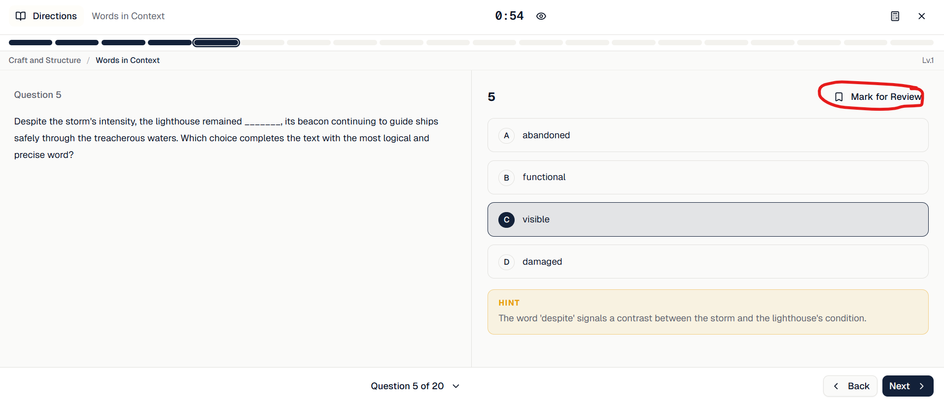

Bug ID BUG-005
Title Hint/Suggestion not displayed after incorrect answer selection
Module Quiz Page
Environment Chrome 120, Windows 11
Build Version NA
Severity High
Priority High
Reported By Nilava (QA Automation Engineer)
Date
13-April-2026
Frequency Always
Precondition User is logged into Athena onboarding quiz
Steps to Reproduce 1. Open the onboarding quiz page.
2. Select the incorrect answer
3. Observe the suggestion area

Actual Result Suggestion/lesson section does not appear.
Expected Result Suggestion should appear immediately after a wrong answer.
Impact
- Learning flow broken
- Users are not guided after mistakes
- Diagnostic quiz loses purpose
- Adaptive learning ineffective

Evidence / Screenshot

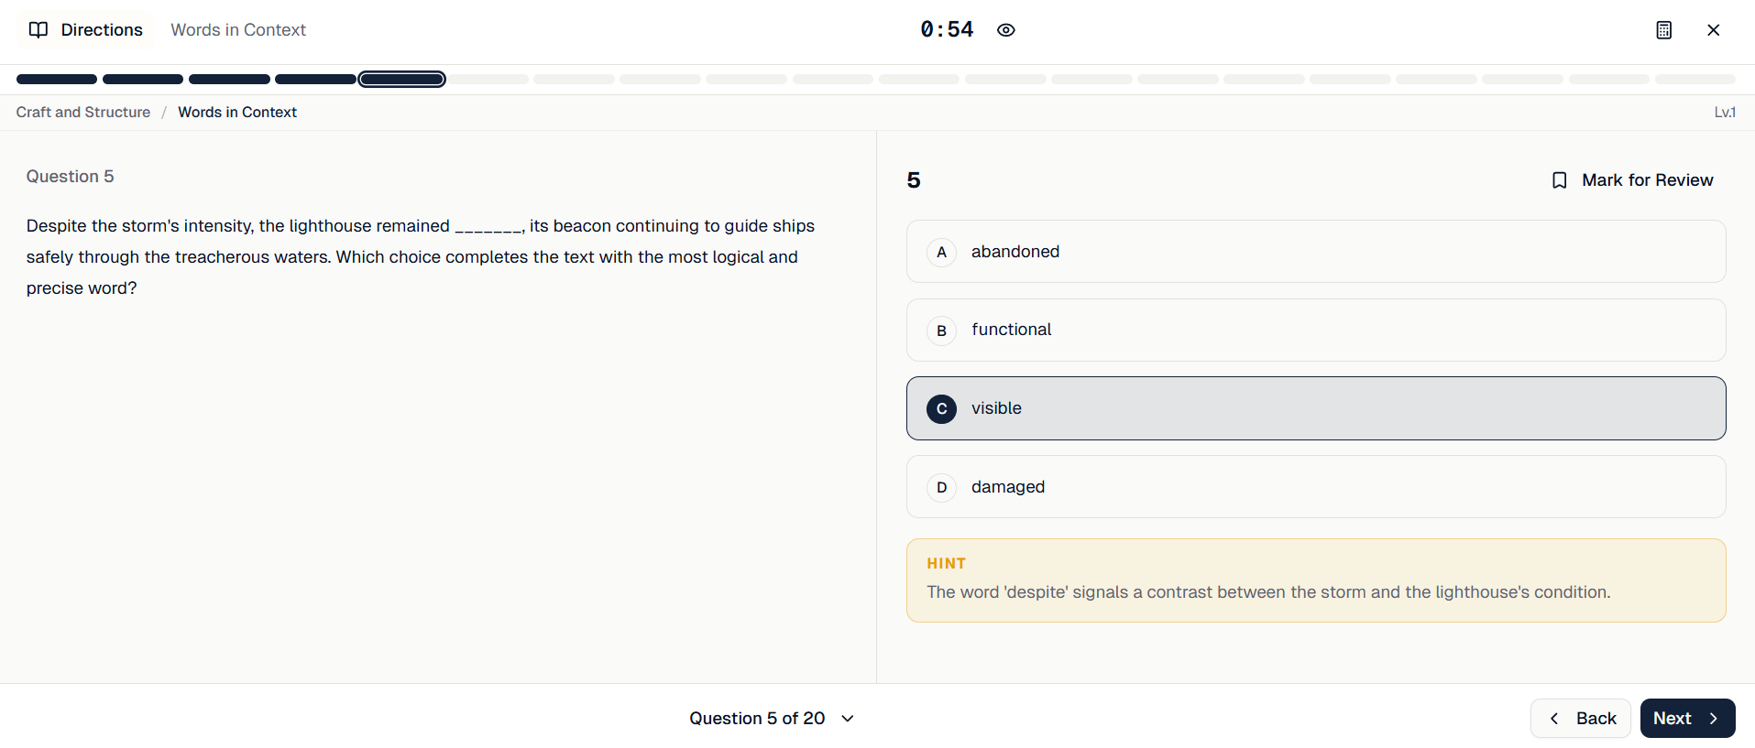

Bug ID BUG-006
Title Answer remains editable after incorrect answer selection
Module Quiz Page
Environment Chrome 120, Windows 11
Build Version NA
Severity Medium
Priority High
Reported By Nilava (QA Automation Engineer)
Date
13-April-2026
Frequency Always
Precondition User is logged into Athena onboarding quiz
Steps to Reproduce 1. Open the onboarding quiz page.
2. Select the incorrect answer
3. Select another option

Actual Result User can change the answer multiple times.
Expected Result Either:
- Answer should lock after first selection
OR
- Clear feedback should reset logic
Impact
- Users can guess until correct
- Diagnostic accuracy compromised
- Score integrity broken
- Learning analytics incorrect

Evidence / Screenshot
Please find the loom video link below
https://www.loom.com/share/78bd25662ba5410285f794c86d22ba9b

